Table of Contents

1.0 Introduction 3

2.0 Assumptions 3

3.0 System Design (Client/Server) 4

3.1 Storyboards 4

3.2 Use Case Diagrams 7

3.3 Use Case Descriptions 7

3.4 Activity Diagrams 9

4.0 Protocol Design (Client/Server) 10

4.1 TCP/IP 10

5.0 Health and Safety Considerations 11

6.0 Implementation 12

6.1 Hardware Requirements 12

7.0 Conclusion 15

8.0 References 16

9.0 Appendix 17

# 1.0 Introduction

The case study of this assignment was using LabView to design and build a contactless car wash controller system. This system can be used to solve the manpower needs and also the time management of a company as the specifications of this system are allowed the customer to self-serve and the fully automated system with machines. Besides, this system relies on water spray without using brushes. In this system, there are two operating modes which are deluxe wash mode and economy wash mode to allow the customer to decide based on their financial condition. Once the system detects the car and the customers finalize their choice with payment, the system will start to run automatically for washing the detected car. This report will include the details of the system design and protocol design, the hardware requirements of the system, the workflow of the system and also the health and safety considerations.

# 2.0 Assumptions

In this case study, several assumptions can be made before creating the program and they are listed as follows:

1. Once the customers selected an operating mode, they are not allowed to make any changes.

2. The payment should be made after the selection mode process and the staff will collect the payment.

3. An emergency stop button will be provided to customers from staff before they enter the car wash system in case any emergency situations happen and the stop button will be collected back once the washing process ends.

4. If the system doesn’t detect the car in the right position, the vehicle out of position LED will activate and the system is not able to run.

5. During the washing process, if the customers immediately pause the process, the amount of time that expires will not count against the wash time. It will resume when the car is properly positioned.

6. The system only allows one purchase selection at a time. The system should not accept a second purchase selection while the system is in operation.

7. The economy wash mode only has the main wash cycle, while the deluxe wash includes the underbody wash cycle, main wash cycle and air-dry cycle.

8. The staff must login first before entering the server system to view the log file.

# 3.0 System Design (Client/Server)

## 3.1 Storyboards

When a customer drives a car to the main entrance of the car wash. They have two options to select which are deluxe wash and economy wash. Once purchase selection is made by the customer, the staff will provide an emergency button to the customer. The emergency button is used for the customer to stop the system immediately when an emergency case happens. Then, the vehicle out of position LED will light out and require the customer to proceed to the next step. If the customer selected the deluxe wash, they will start from the underbody wash cycle. However, if the customer selected the economy wash, they will start from the main wash cycle.

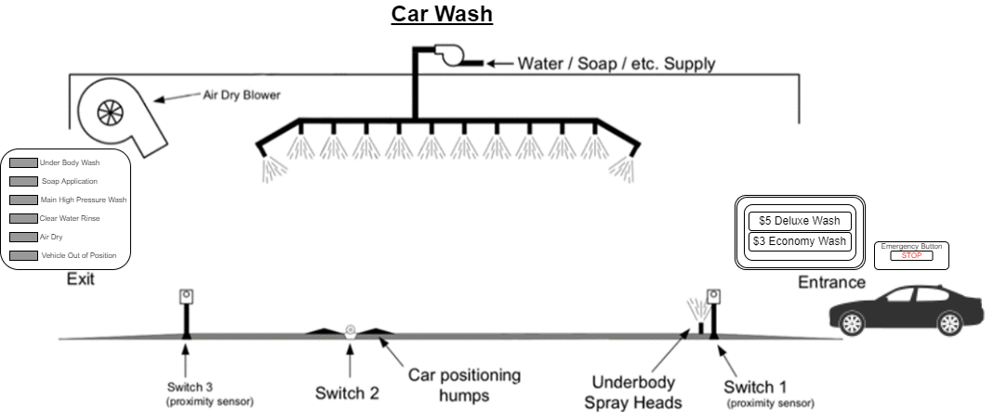

Figure 1: Main entrance

When they drive their vehicle to the right position, the vehicle out of position LED will off and the underbody wash LED will on which means the underbody wash cycle is running. Then the timer will start to count down from 10 seconds. Once the cycle is finished, the vehicle out of position LED will light out again to inform customers to move their vehicle to the next step.

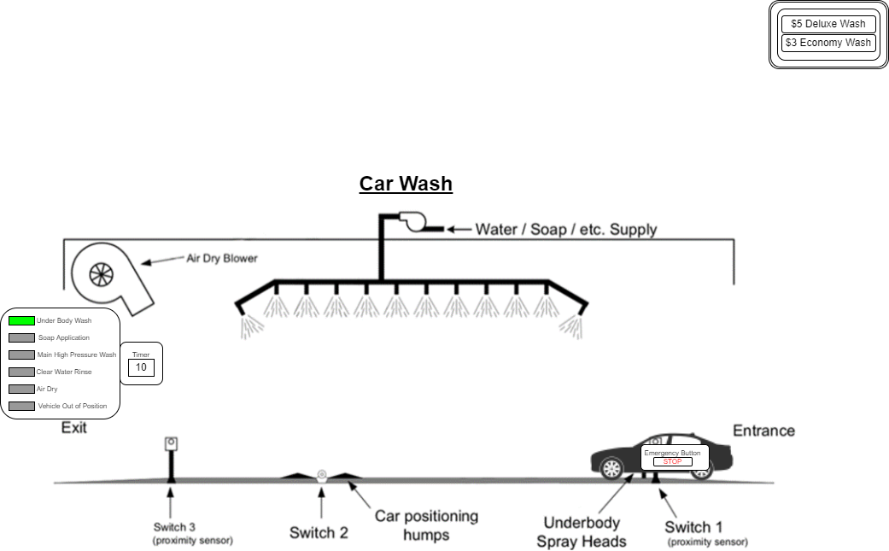

Figure 2: Underbody Wash cycle

The car wash system will be provided three-cycle in the main wash cycle which are soap application, main high-pressure wash and clear water rinse. First, the soap application LED will light up when the vehicle out of position LED is off. Once 5 seconds of soap application cycle is done, then the system will proceed to the main high-pressure wash cycle for 5 seconds and continue with the clear water rinse cycle for 7 seconds.

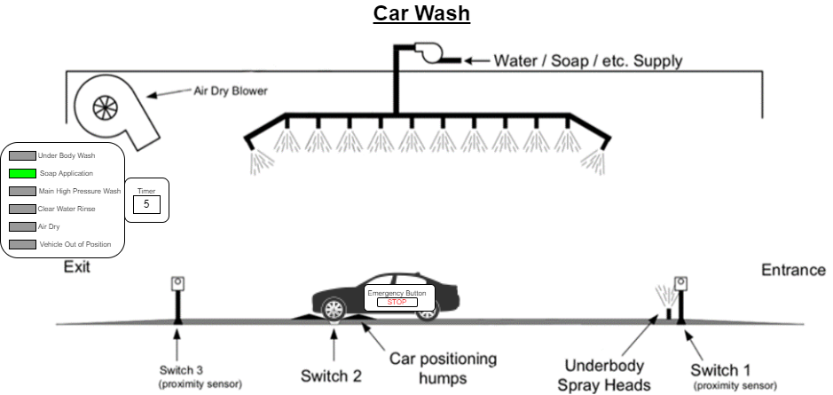

Figure 3: Main Wash cycle

The air-dry cycle is only available for the customer who selects the deluxe wash. Air dry LED will light up within 10 seconds. Then the car wash is done when the air-dry LED is turned off.

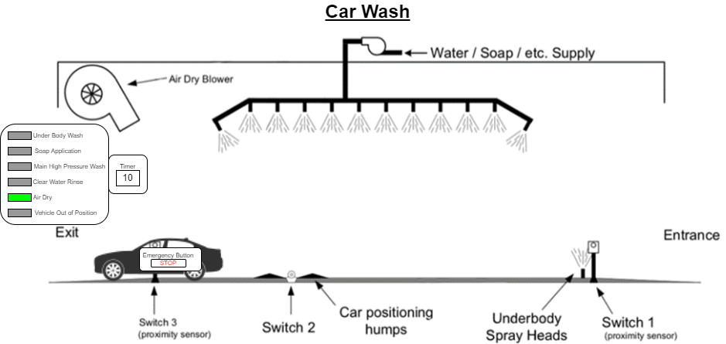

Figure 4: Air Dry cycle

At the exit, the customers need to return the emergency button to the staff and they are available for leaving the car wash area. Then, the purchase selection is available to the next vehicle for another wash.

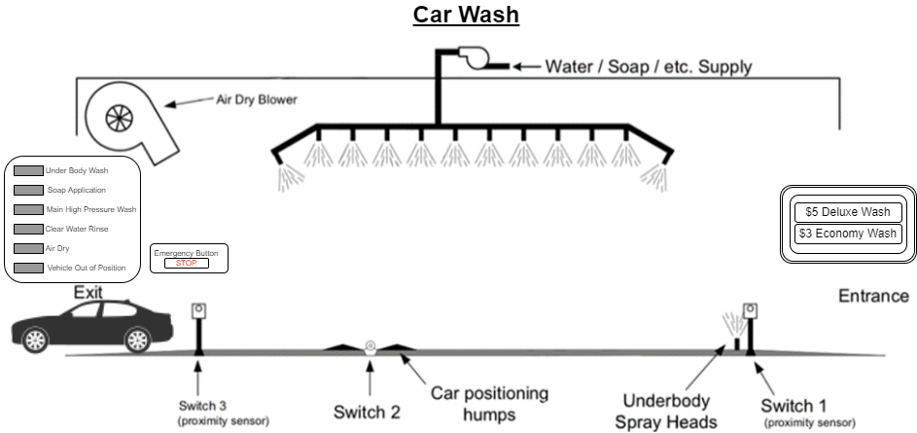

Figure 5: Exit

## 3.2 Use Case Diagrams

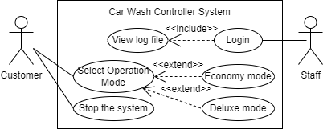

Figure 6: Use case diagram

## 3.3 Use Case Descriptions

|  |  |
| --- | --- |
| Name | Select Operation Mode |
| Objective | To allow customers either select economy mode or deluxe mode |
| Actor | Customer |
| Main Flow | 1. Select Economy mode 2. Run soap application cycle 3. Run main high-pressure wash cycle 4. Run clear water rinse cycle 5. Send record to the server 6. Select Deluxe mode 7. Run underbody wash cycle 8. Run soap application cycle 9. Run main high-pressure wash cycle 10. Run clear water rinse cycle 11. Run air dry cycle 12. Send record to the server |
| Alternative Flow | 1a. Stop the system with the emergency button  1b. Vehicle not in the right position  2a. Stop the system with the emergency button  2b. Vehicle not in the right position |
| End Point | The vehicle is done with the car wash process |

Table 1: Select Operation Mode

|  |  |
| --- | --- |
| Name | Stop the system |
| Objective | To stop the system when any emergency case happens. |
| Actor | Customer |
| Main Flow | 1. Stop the car wash controller system |
| Alternative Flow | None |
| End Point | The system is stopped |

Table 2: Stop the system

|  |  |
| --- | --- |
| Name | Login |
| Objective | To access the server of the system |
| Actor | Staff |
| Main Flow | 1. Insert user name 2. Insert password 3. View log file record |
| Alternative Flow | 1a. Invalid user name  2a. Invalid password  3a. File record no found |
| End Point | The staff can view the log file record |

Table 3: Login

## 3.4 Activity Diagrams

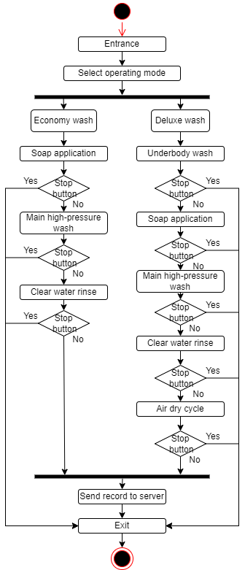

Figure 7: Activity Diagram

# 4.0 Protocol Design (Client/Server)

## 4.1 TCP/IP

Transmission Control Protocol/Internet Protocol (TCP/IP) is used to interconnect devices for transferring data. In the car wash controller system, we need to transfer the data of date, time and type of wash from the client side to the server side. In figure 8, I used the 3333 port to connect the localhost IP address, then I transfer the byte and string of data to the server side.

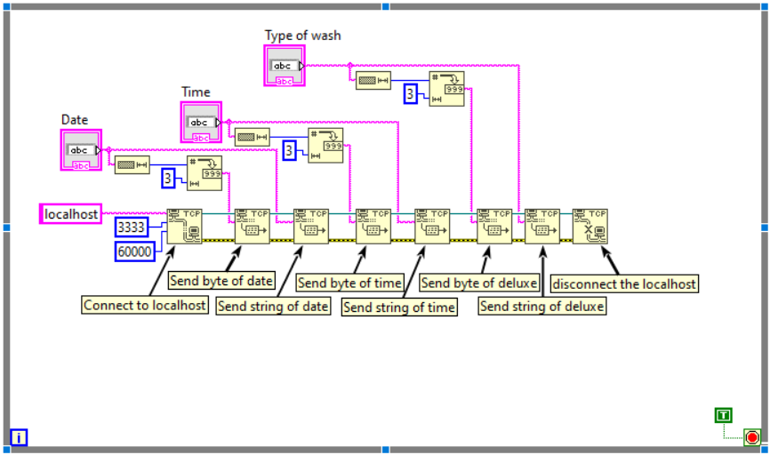

Figure 8: Client protocol design

On the server side as shown in the figure 9, the port must be the same as the port of the client side, so the connection can be established. Then, the server can receive the byte and string of date, time and type of wash from the client side. Next, the data received will be created as an array and recorded into a relative text file of a device.

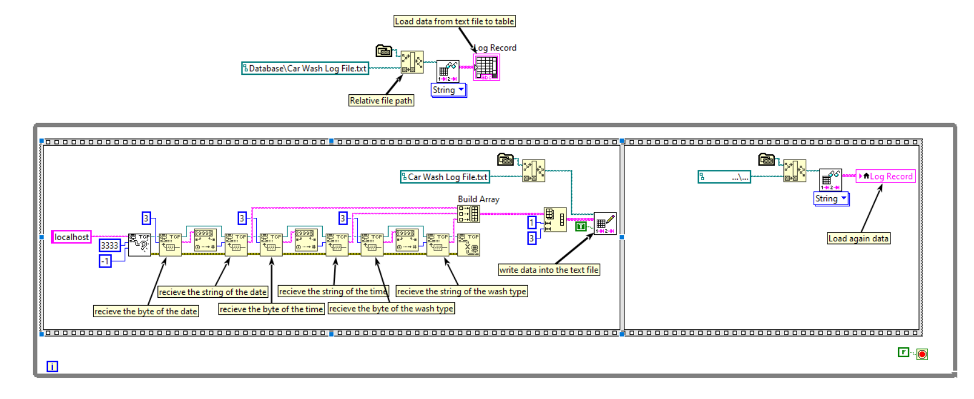

Figure 9: Server protocol design

# 5.0 Health and Safety Considerations

Health and safety are important and necessary factors that a developer should be considered when developing a system, these factors must be included in this system. As this system is designed to be contactless and closer proximity to the customers, it is important for us to think about all the possible risks within the system, so we can prevent or reduce the chances of an accident happening.

Firstly, as a staff, it is hard to determine the situation of a customer in a car during the washing process. An emergency stop button should be provided to the customer, so the customer can immediately stop the system in case to prevent any situation happens on them. For example, they suddenly open the car doors or windows, no comfort, and car under damage.

Besides the system should put a fire extinguisher, so the staff can use it when the car or the system suddenly spark a flame or on fire. Moreover, the building of the system should be installed a fire alarm to alert people for evacuating from the fire zone.

Furthermore, the lane of each section in the system should put a small hump to prevent the car slip out of the origin position as we need to consider the customer forgetting to step the brakes or even pull the handbrake. Besides, the LED light of the car wash indicator should be placed at the end of the car wash controller system so the customer can determine whether their vehicle is in the right position and also the flow of the washing process.

Apart from that, the staff must make sure there are no consists of any tools, materials or other objects lying on the driveways and floors to reduce the accidents and provided a safe environment for the customer. The staff also need to wear slip-resistant shoes to prevent slips and falls in the workplace as the floor may consist of spills such as oil, soap, water and wax.

Next, the soap used in the system should not harmful to humans. We need to consider staff or customers may have a chance to touch the soap, so if the soap is harmful to humans, there may happen several situations. For example, the chemical hazards in the soap will harm the car paint, cause the human respiratory issue and skin irritation. Besides, as the soap will emission together with water and flow to the river, we need to ensure the soap is environmentally friendly, so it would not destroy the ecosystem of water and pollute the river.

# 6.0 Implementation

## 6.1 Hardware Requirements

In the car wash controller system, there is various hardware needed for the system to run optimally.

First, a proximity sensor is needed for the system to detect the car is in the right position. The proximity sensor must be waterproof to prevent sensor malfunctions. Therefore, the PNI sensor’s PlacePod is recommended as it can provide accurate vehicle detection and is stable over harsh environments (PNI Sensor Corporation, 2018).

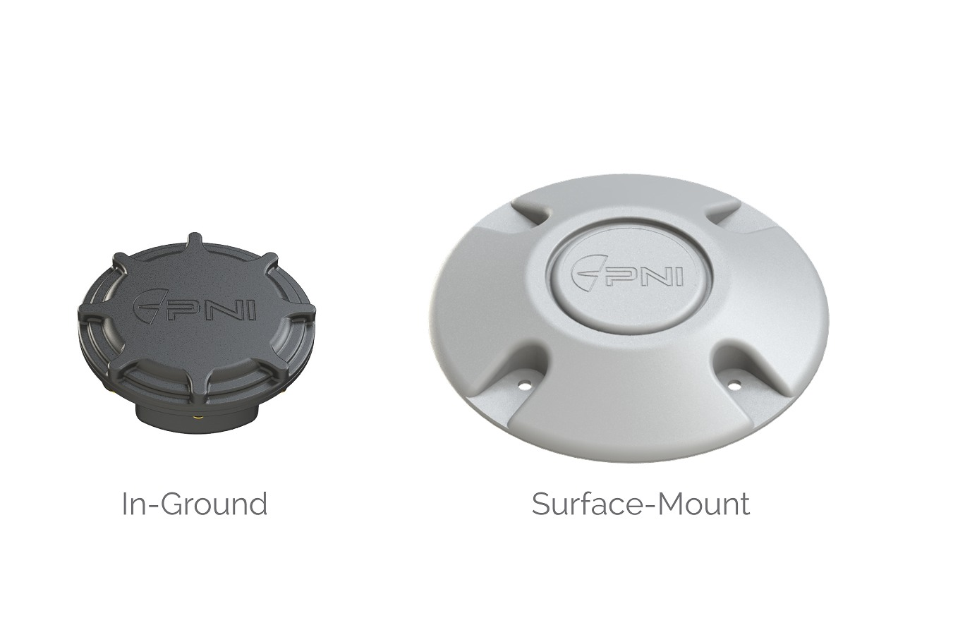

Figure 10: proximity sensor

Second, car positioning humps is needed for fixed the vehicle position and also can prevent the vehicle slip out from the lane. It is also used to prevent accidents happen. The vehicle conveyor belts are used as the car positioning humps for car wash as they can minimize the risk of accidents for the car wash process and customers (Minda, 2022).

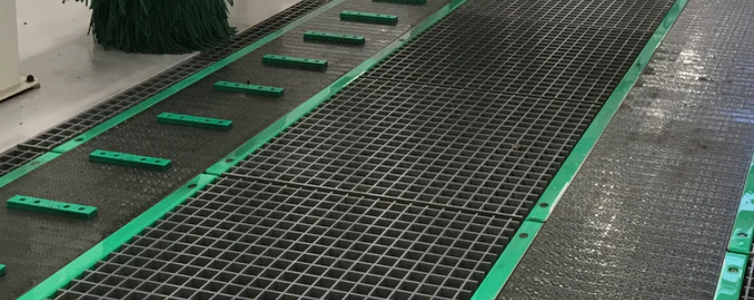

Figure 11: car positioning humps

Third, underbody wash is one of the cycles of the system. Therefore, Ss-FM4 Sino Star undercarriage cleaner is needed to clean the underbody of the vehicle. It has a max of 4000psi to ensure the extremely dirty part of the vehicle’s underbody can be removed (Sino Star, 2022).

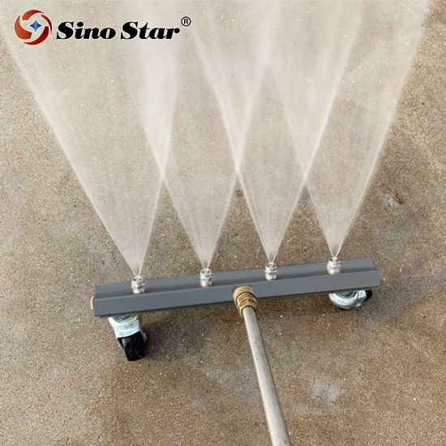

Figure 12: underbody wash spray heads

Fourth, air dry is one of the cycles of the system. Therefore, an air-dry blower is needed to remove water from the exterior surfaces of a car (Meagan, 2017).

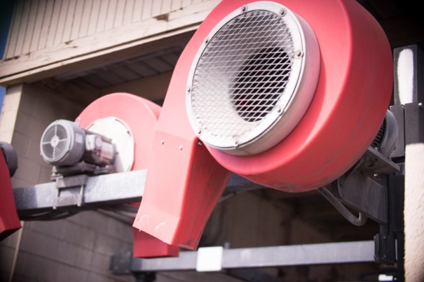

Figure 13: air dry blower

Fifth, the main component of the system is the car wash machine which contains the soap application cycle, high-pressure wash cycle and water rinse cycle. Therefore, the fully automatic touchless car wash machine by high-pressure water DY-W360 model is needed to conduct the main wash cycle. It has 80 Bars of high-water pressure and can conduct two different washing modes which are deluxe wash and economy wash. It also has a feature of residue-free (Liya, 2022).

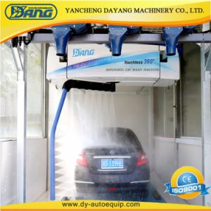

Figure 14: car wash machine

Sixth, the LED lights are needed to show the status of each cycle of the system. It is used to allow the customer to know the current task of the system. Therefore, a rectangle LED panel light is used in the system. It has 12V of voltage and 6w of wattage to support various lightness of the LED light (TLW, 2022).

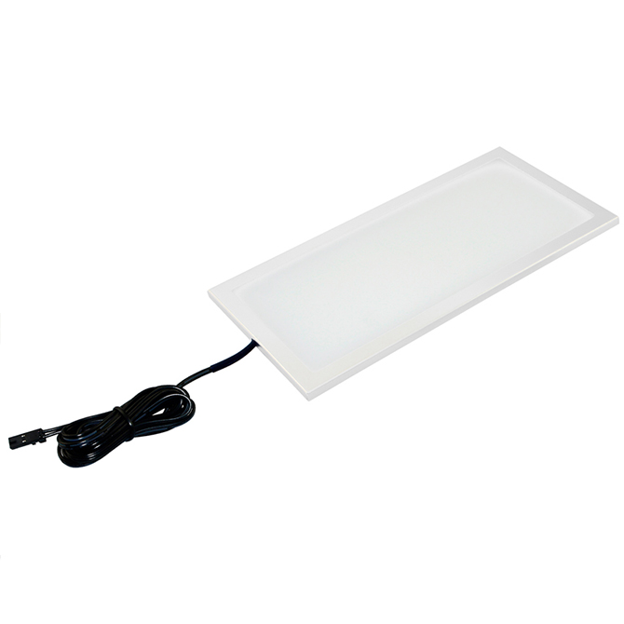

Figure 15: LED light

# 7.0 Conclusion

In conclusion, the car wash controller system was completely implemented within 7 weeks by using LabView and it works efficiently. The system is also designed as safer for the operation and customers to prevent any accidents happen. However, there are also have some limitations to the system. The car wash system is not suitable for large vehicles such as bus, lorry, truck, etc. Besides, for those customers who purchase economy wash, their vehicles will have some water spots if they do not conduct the air-dry cycle. Moreover, the system also can implement the ewallet system for collecting payment to reduce the contact between customers and staff. There are also have some enhancements that can be made within the system such as using a count down timer instead of a count up timer to easier for the customer to view the duration of each cycle and also can add an alarm to warn the customer if their vehicle is out of position. Within this assignment, I learned a lot of knowledge regards the implementation of a program by using LabView and I believe these pieces of knowledge are useful for me in my future career.

# 8.0 References

Aashish, M. (29 August, 2017). *Counting the Number of Matches in a String in LabVIEW*. Retrieved 3 March, 2022, from ni.com: https://forums.ni.com/t5/Example-Code/Counting-the-Number-of-Matches-in-a-String-in-LabVIEW/ta-p/3530807

Exeliq. (28 November, 2021). *Learn how to Quickly Create a Custom Timer in LabVIEW | LabVIEW tips and tricks | LabVIEW Basics*. Retrieved 3 March, 2022, from youtube.com: https://www.youtube.com/watch?v=RMKBJb9FrVg&t=244s

Liya, L. (2022). *Non Contact Leisuwash 360 Automatic Car Wash Equipment with Air Drying Blowers*. Retrieved 3 March, 2022, from made-in-china.com: https://dyautoequip.en.made-in-china.com/product/wNWQIiCKlhkA/China-Non-Contact-Leisuwash-360-Automatic-Car-Wash-Equipment-with-Air-Drying-Blowers.html

Meagan, K. (24 August, 2017). *Carwash equipment 101*. Retrieved 3 March, 2022, from carwash.com: https://www.carwash.com/carwash-equipment-101/

Minda. (2022). *TAILOR-MADE CONVEYING TECHNOLOGY FOR VEHICLE LEAKAGE TESTING/CAR WASH TECHNOLOGY*. Retrieved 3 March, 2022, from minda.com: https://www.minda.com/en/car-washes/leakage-testing-car-wash-technology/vehicle-conveyor-belts

PNI Sensor Corporation. (2018). *PlacePod Smart Parking Sensor*. Retrieved 3 March, 2022, from partners.sigfox.com: https://partners.sigfox.com/products/placepod-smart-parking-sensor

Sino Star. (2022). *Ss-FM4 Sino Star 13" High Pressure 4000psi Washer Car Undercarriage Cleaner Under Body Chassis Water Broom Washer*. Retrieved 3 March, 2022, from made-in-china.com: https://m.made-in-china.com/product/Ss-FM4-Sino-Star-13-High-Pressure-4000psi-Washer-Car-Undercarriage-Cleaner-Under-Body-Chassis-Water-Broom-Washer-944561225.html

TLW. (2022). *SLIM RECTANGLE LED RECTANGLE PANEL LIGHT 6W*. Retrieved 3 March, 2022, from tlwglobal.com: https://tlwglobal.com/product/slim-rectangle-led-panel-light-6w/

# 9.0 Appendix

User Manual-Client Side

Rules

1. Customers are allowed to make a purchase selection within Deluxe wash and Economy wash.

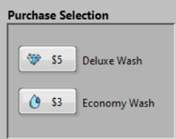

Figure 16: Purchase Selection

2. Only one selection is allowed to make, once the customer is selected, they are not allowed to regret and reverse their vehicle for another selection.

3. Only one vehicle is allowed for one car wash operation.

4. Once the customer made the selection, the staff will provide an emergency stop button to the customer as shown in figure 17.



Figure 17: Emergency stop button

6. Customers are allowed to press the emergency stop button only if emergency situations happen.

7. During car wash operation, drivers and passengers are not allowed to open the car windows or doors.

Deluxe Wash Operation

1. Once made a selection, the vehicle out of position LED will light up and the customers need to drive their vehicle to the underbody wash position as shown in the figure 18. Then, the vehicle out of position LED will turn off and the underbody wash LED will light up which means the underbody wash is running within 10 seconds as shown in the figure 19.

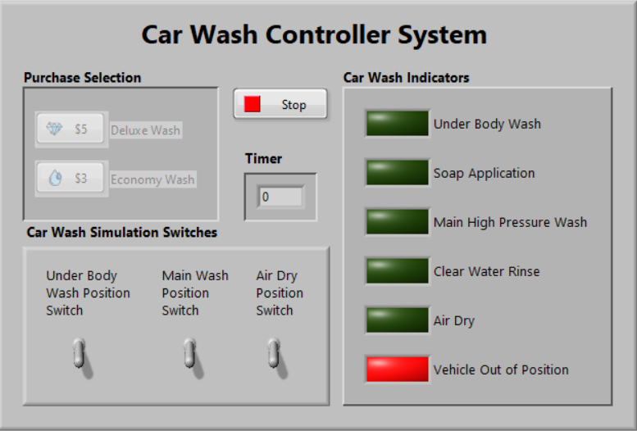

Figure 18: Under Body Wash Position (Switch off)

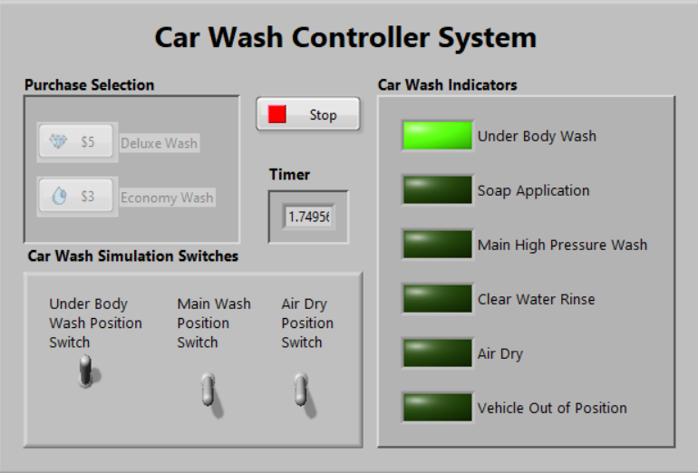

Figure 19: Under Body Wash Position (Switch on)

2. Once the underbody wash cycle is done, the vehicle out of position LED will light up again to alert the customer to drive their vehicle to the main wash position as shown in figure 20. Once the proximity sensor detected the vehicle, the system will begin to perform the soap application cycle within 5 seconds, the high-pressure wash cycle within 5 seconds and the clear water rinse cycle within 7 seconds as shown in the figure 21,22,23.

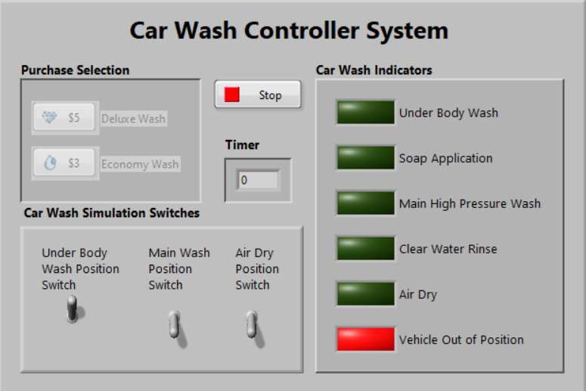

Figure 20: Main Wash Position (Switch off)

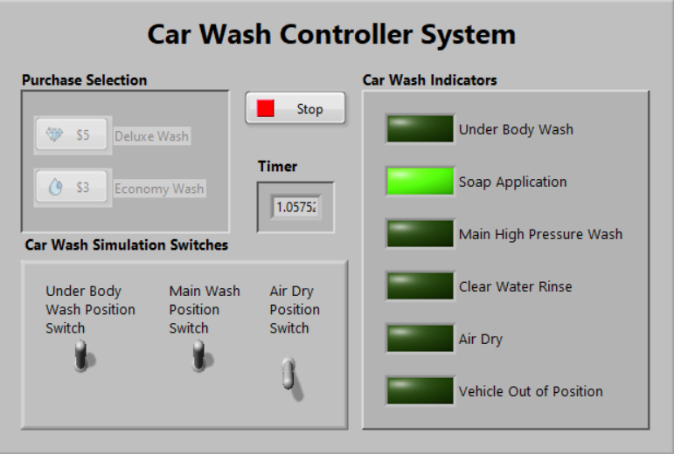

Figure 21: Main Wash Position 1 (Switch on)

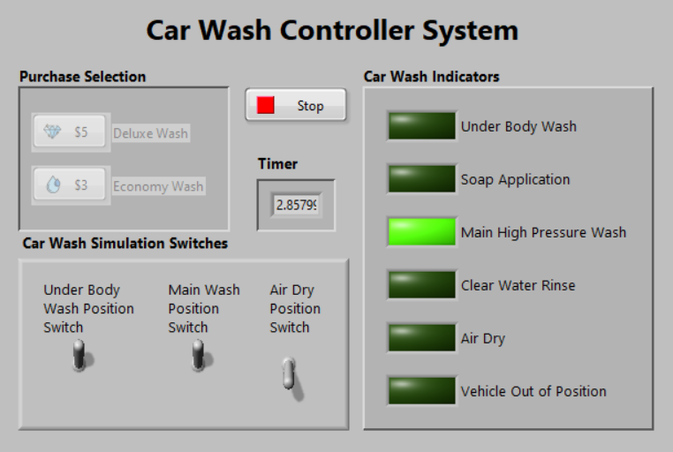

Figure 22: Main Wash Position 2 (Switch on)

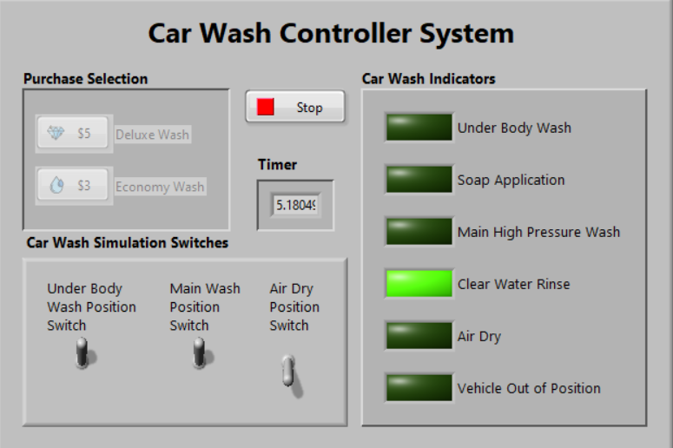

Figure 23: Main Wash Position 3 (Switch on)

3. Once the main wash cycle is done, the vehicle out of position LED will light up again to alert the customer to drive their vehicle to the air-dry position as shown in figure 24. Once the proximity sensor detected the vehicle, the system will begin to perform the air-dry cycle within 10 seconds as shown in figure 25.

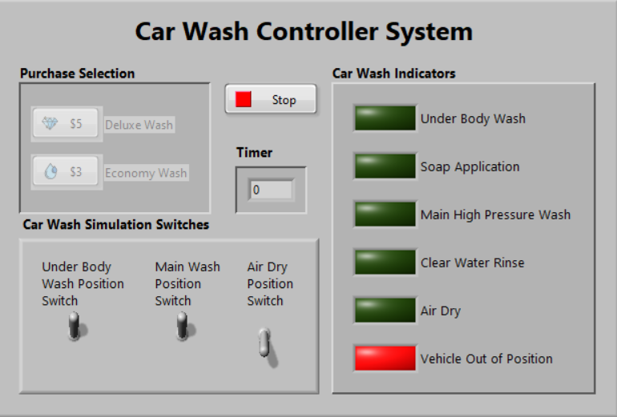

Figure 24: Air Dry Position (Switch off)

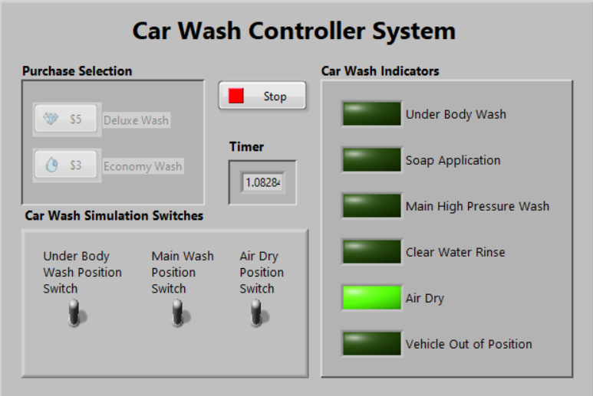

Figure 25: Air Dry Position (Switch on)

4. Once the air-dry cycle is done, the customers need to drive their vehicle to the end position to return the emergency button to the staff. Then, they may exit the car wash.

Economy Wash Operation

1. Once made a selection, the vehicle out of position LED will light up and the customers need to drive their vehicle to the main wash cycle as shown in figure 26. Once the proximity sensor detected the vehicle, the vehicle out of position LED will turn off and the system will begin to perform the soap application cycle within 5 seconds, the high-pressure wash cycle within 5 seconds and the clear water rinse cycle within 7 seconds as shown in the figure 27,28,29.

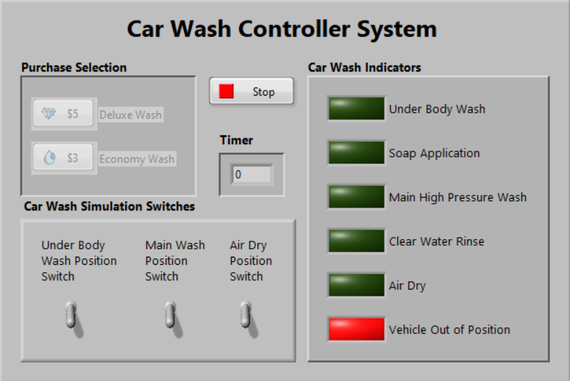

Figure 26: Main Wash Position (Switch off)

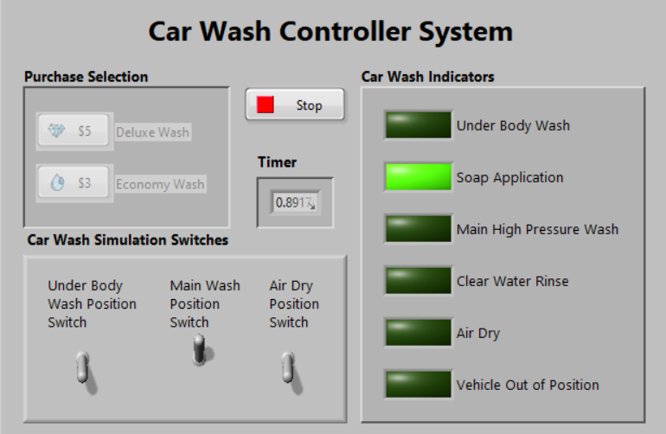

Figure 27: Main Wash Position 1 (Switch on)

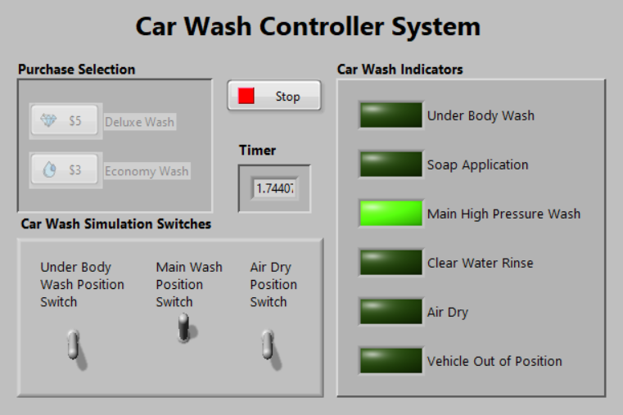

Figure 28: Main Wash Position 2 (Switch on)

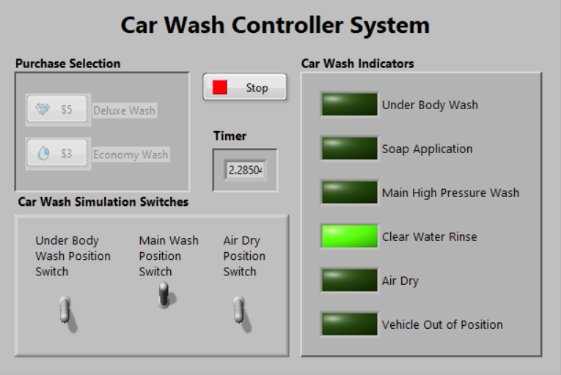

Figure 29: Main Wash Position 3 (Switch on)

2. Once the main wash cycle is done, the customers need to drive their vehicle to the end position to return the emergency button to the staff. Then, they may exit the car wash.

User Manual – Server side

Rules

1. Staff is required to insert the user name and password before login in the server side to view the log record of the car wash system as shown in figure 30.

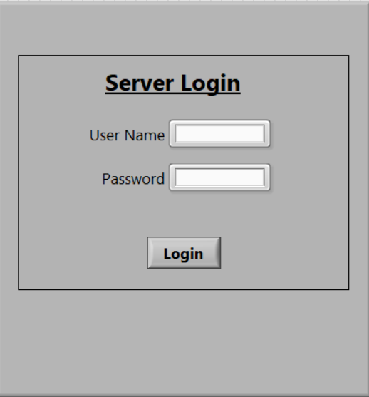

Figure 30: Server Login

2. If the user name and password are wrong, the staff is not allowed to login into the server.

3. Once the staff login into the server, they will view a log record which contains date, time and type of wash. It also contains the total number of deluxe wash and the total number of economy wash.

4. The staff can click the logout button if they want to quit the server.

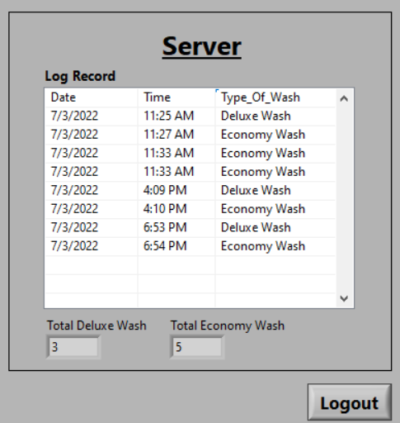

Figure 31: View Log Record